Truba QnA

MAJOR PROJECT REPORT

Submitted in partial fulfillment of the requirement for the Degree of Bachelors of Engineering in Computer Science & Engineering

Submitted To
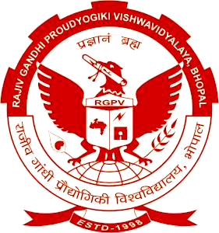

[RAJIV GANDHI PRODYOGIKI VISHWAVIDYALAYA, BHOPAL (M.P.)]

Submitted By
Abhishek Argarey (0114CS161004)
Amber Pandey (0114CS161020)

Under the Guidance of
Prof. Prateek Oswal
Assistant Professor
(Department of Computer Science & Engineering)



DEPARTMENT OF COMPUTER SCIENCE & ENGINEERING
Truba Institute of Engineering & Information Technology, Bhopal
SESSION: 2019 - 2020

